Exploring the Limitations of Justifiable Machine Learning to Retina OCT Scans of Choroidal Neovascularization
Introduction
In the clinical use of artificial intelligence and machine learning, clinicians, lawmakers, and researchers all are requesting the verification of these tools through explanations (Ghassemi et al., 2021). Explanations refers to the methodological reasoning as to why a machine learning model made a specific decision. This reasoning is especially sought after in patient care use as the safety of the patient as well as the liability of the doctor remains a priority to users of these models. In machine learning and artificial intelligence models, the idea of a black box is what plagues a lot of doctors when defending the use against these tools. The unknown process of complex models makes users feel uneasy and the common idea is that viewable explanations are representative of a model’s ability to perform a task (Tonekaboni et al., 2019). Ghassemi et al. defends the idea that this mode of thinking brings nothing but false hope to the health care field that we will have highly functional and complex models that are also visibly explainable in the field. The most useful models require high complexity. For patient care, this is much more relevant as these applications require the most accuracy and input data as other machine learning uses.
Models that are easily explainable do not hold the complexity required to be used in a clinical setting. These easily explained models, also known as inherently explainable models are simplistic and easily identifiable in most models. A good example is in linear regression models where the slope coefficient can represent the power and the direction of the relationship between variables, thus explaining the model’s ability. At the same time, these explain-ability methods can be overwhelming as complexity increases and in the case of a model error, it can be difficult to locate the origin of the mistake. Another implication is the inherent explain-ability is often overtrusted by users and some tools are misused by data scientists and cannot truly display the explain-ability accurately (Kaur et al., 2020). For practical use, models of high complexity with high dimensional data such as image, sound, text, and language exceed inherent explain-ability. Complex models often use post-Hoc explain-ability tools that focus on understanding the decision-making process of a machine learning model (Ghassemi et al., 2021). The most commonly used post-Hoc explain-ability forms use heatmaps or saliency maps (Selvaraju et al., 2017). These figures output the regions of the input data that were the most impactful to the machine learning model’s output. Mathematically, these are normally regions that have the highest scores as compared to a Kernel matrix (in the example of image data). The main flaw to these approaches lies in the interpretation of the heatmaps for example after using the tools. Post-Hoc explainability methods still require a human to confirm whether the model was looking in the correct spot and making an accurate decision. This becomes problematic when altercations, called adversarial attacks, result in no change in the heatmap explain-ability output. Adversarial attacks aim to alter data to forcibly result in incorrect decisions (Selvaraju et al., 2017). As a result of these attacks, the heatmaps visibly show little to no change in the regions at regions which models make their decisions. This makes the post-Hoc heat map approach hard to trust as it still is applicable to a completely wrong output (Ghassemi et al., 2021).
Objectives
In this study, the aim is to observe the ability for post-Hoc explainability using GradCAM heatmaps in retina optical coherence tomography (retina OCT). Specifically, we are observing the ability of Python Keras convolutional neural networks to classify between healthy retina OCT’s and ones with Choroidal Neovascularization, a disorder that causes in the growth of blood vessels through the Bruch membrane of the retinal epithelium from the choroid.
From the previous literature, the Keras convolutional neural network will correctly classify between healthy and diseased with choroidal neovascularization, however, the GradCAM heatmap will fail to provide any significant explanation to any classification nor misclassification of any retinal OCT scan. This study will further emphasize the unimportance of explainable machine learning or artificial intelligence models in clinical use through the success of creating a functional black box image classifier.
Method
To program the machine learning model, we used Python and jupyterlab to organize and display all results. Data for the retina optical coherence tomography images was taken from a publicly available databank called “Kaggle”. The dataset had a total of 84 495 images split into 4 categories. Each category had a training, testing and validation dataset. For our study, we used the Normal and CNV diseased categories. To train the model we had 63 520 images split into the two classes above. To validate our model, we had 16 images split into two classes. The convolutional neural network classified CNV images as a zero and healthy images as a one. The model contained four hidden layers, each with an increasing number of kernels, each kernel being a three-by-three matrix per layer. Each hidden layer also used an activation function of ReLu due to its common use in image classification. After the last layer, the model flattened the data and used a sigmoidal function to get the final output. We used a binary cross-entropy loss function with a learning rate of 0.001. We fitted the model to the training data with five steps per epoch and with a total of one hundred epochs. Accuracy was scored against a validation dataset to ensure there was limited training bias. After the fitting, we had a loss of around 0.3 for the training data and 0.1 for the validation data. We also had an accuracy of close to 1 for both the training and validation datasets. Through visual output, we identified a few errors in our classifier, all of which have image defects, such as white boarders or rotated images, that could explain the incorrect classification.
GradCAM is a machine learning decision visualizer that uses the last hidden layer of the convolutional neural network to determine the gradient for the decision heatmap. From the GradCAM website, the function was implemented in our code and output the heat map in relation to each image. The output included the original image, the heat map, and an overlay of both the heatmap and the original image.
Results
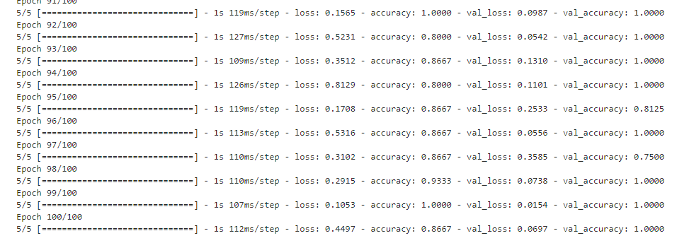
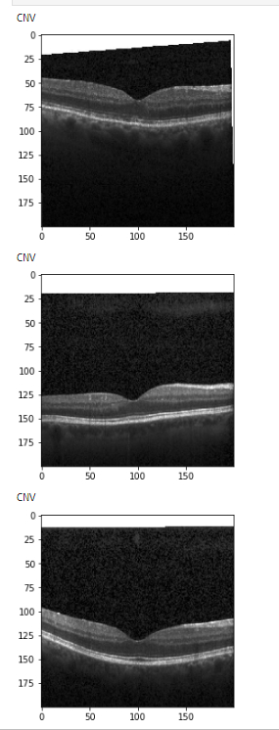
Figure 1: The fitting of our training data to our convolutional neural network image classifier model. The training data had 63 520 images with 16 validation images. The training data was fit with 100 epochs and 5 steps per epoch. We had an average training data loss of about 0.3 with a close to 1.0 accuracy and a validation loss of about 0.1 with a close to 1.0 accuracy.
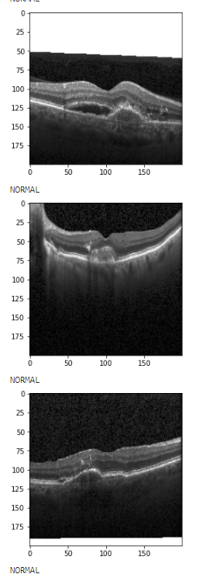
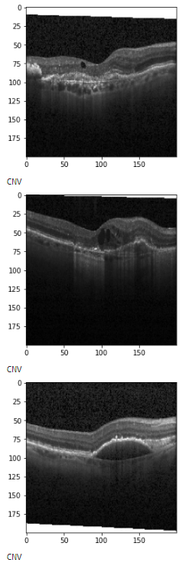
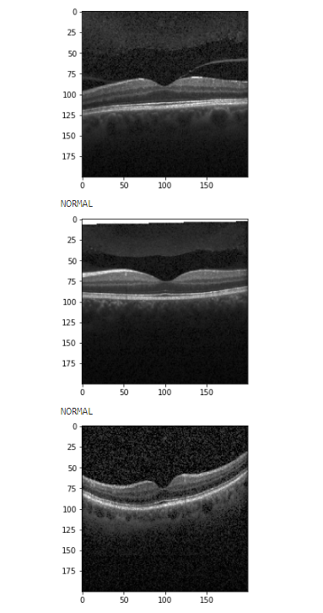
B)
A)
Figure 2: Classification of the testing dataset. A) Classification of the healthy data set with correct classification examples on the left and incorrect classification examples on the right. B) Classification of the CNV data set with correct classification examples on the left and incorrect classification examples on the right.
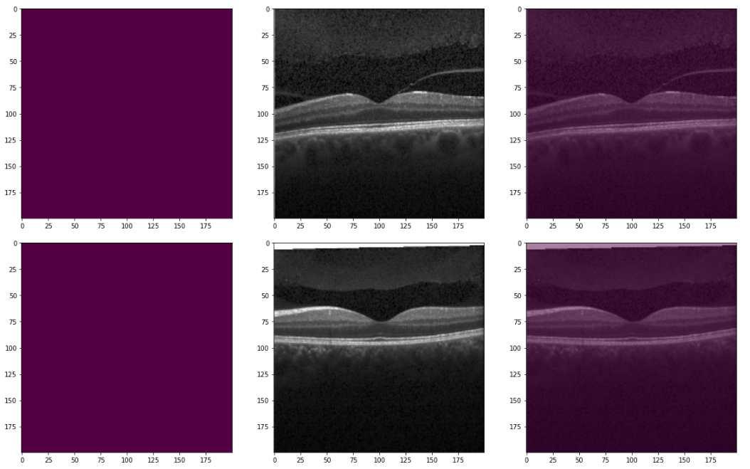
Figure 3: GradCAM heat maps of the healthy dataset through the model. The heatmap is on the left, with the original image in the center and the overlayed imaged on the right.
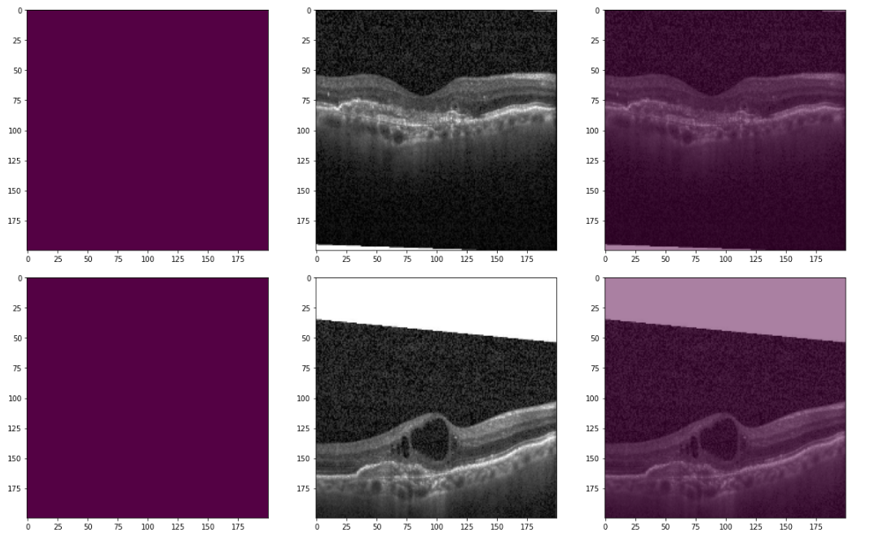
Figure 4: GradCAM heat maps of the CNV dataset through the model. The heatmap is on the left, with the original image in the center and the overlayed imaged on the right.
Conclusions
From Figure 1, we can conclude that our model successfully trained against the training dataset and was validated to be functional against the validation dataset. With a low loss output and almost 1.0 accuracy in both the training and validation data after 100 epochs, we can conclude that we successfully fit our model to be unbiased towards the training data. From Figure 2, we observed the functionality of the model against a testing dataset of healthy (figure 2, A) and diseased with choroidal neovascularization (Figure 3, B). From this summary of the output of all the testing images, we can confirm the success of the model as the majority of the images were correctly classified with the exception of five images from the normal dataset and 3 images from the CNV dataset being misclassified (5/242 = 0.02 error, 3/242 = 0.01 error, respectively). To observe the ability of heatmaps to explain the decision-making of the model, we used the GradCAM class to create heatmaps in Figure 3 and 4 for the healthy and CNV dataset respectively. The examples in Figures 3 and 4 reflect all the images from the output. From the left-most images we see that the heatmaps failed to present any identification of regions used to make the decision of healthy or CNV. Furthermore, looking at the far-right image, the overlay reflects this conclusion as the entire image is a single color. This result could be explained through the improper use of the GradCAM class taken from Selvaraju et al. This result could also be because of the thin lines that retina OCT scans show that make it difficult for the model to identify edges and borders to create the GradCAM heatmap. This error reflects the literature as heat maps have been seen to be error-prone and produce results even when the input image is resulting in an incorrect output (Ghassemi et al., 2021). From this result, we can conclude that the use of heat-maps in this study failed to provide justification for the black box convolutional neural network image classifier of retina optical coherence tomography scan images. The model however, was successful in identifying different images as healthy or diseased with choroidal neovascularization, meaning that the model was able to obtain information from the images and create a successful classification despite the inability of the heatmaps to explain how this decision was made.
Future Directions
There are many other aspects to explainable machine learning and artificial intelligence. The current state of clinical machine learning tools is stuck due to the legislation around explainable models. This study will hopefully provide another route to abolishing the requirement for explain-ability and provide evidence that explain-ability does not reflect performance. In the future, we can aim to observe other image-based diagnosis methods in health care to elucidate similar results, further pushing the claims made by Ghassemi et al. The use of adversarial attack methods could also be observed and if the altercation of images can be detected and explained through GradCAM heatmaps, and similarly, can we use adversarial attacks to validate machine learning models in health care to accelerate the deployment of artificial intelligence tools in patient care.

References
Ghassemi, M., Oakden-Rayner, L., & Beam, A. L. (2021). The false hope of current approaches to explainable artificial intelligence in health care. The Lancet. Digital health, 3(11), e745–e750.
Kaur, H., Nori, H., Jenkins, S., Caruana, R., Wallach, H.M., & Vaughan, J.W. (2020). Interpreting Interpretability: Understanding Data Scientists' Use of Interpretability Tools for Machine Learning. Proceedings of the 2020 CHI Conference on Human Factors in Computing Systems.
Selvaraju, R. R., Cogswell, M., Das, A., Vedantam, R., Parikh, D., & Batra, D. (2017). Grad-cam: Visual explanations from deep networks via gradient-based localization. In Proceedings of the IEEE international conference on computer vision (pp. 618-626).
Tonekaboni, S., Joshi, S., McCradden, M.D. &amp; Goldenberg, A.. (2019). What Clinicians Want: Contextualizing Explainable Machine Learning for Clinical End Use. Proceedings of the 4th Machine Learning for Healthcare Conference in Proceedings of Machine Learning Research 106:359-380

